Methods Summary: CatFR1 & CatFR2

General Design
- Introductory video describing the task
- Practice list preceding first experimental list
- 12 word lists; 25 lists per session; two sessions on consecutive days
- 10 second countdown preceding each list
- Encoding: 1600ms word presentation. Randomly jittered ISI 750-1000ms.
- Distractor (20s): A+B+C = ? math problems, where A/B/C are random integers 1-9
- Retrieval (30s): free recall in any order
- Time on task for 25 lists/session: ~ 34 min

Task Schematic
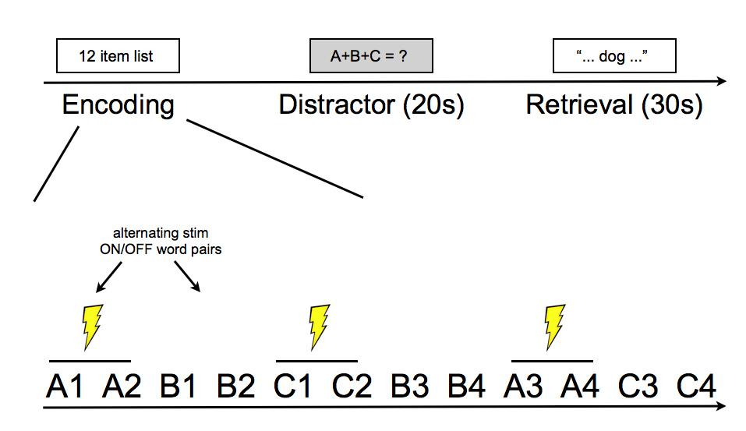

Word Pool Construction
- The word pool was generated via a series of pilot studies conducted on Amazon Mechanical Turk. First, a set of 40 participants generated lists of exemplars from 28 categories. The resulting exemplars were sorted according to the number of participants that produced that specific exemplar. The top 25 exemplars from each category were then selected for the second pilot study (# of participants that produced each exemplar in the top 25 set, M = 19; range = 7-40).
- In the second pilot study, a set of 45 participants rated (on a 1-7 scale) each of the 25 items from the 28 categories in terms of how ‘typical’ the item is of all members of the category.
- From these ratings, the 12 most prototypical items from each category were selected. The three categories with the lowest mean prototypicality across the 12 exemplars were discarded, leaving 25 categories for inclusion in the study. This process ensured that the exemplars that were chosen for the word pool were drawn only from highly prototypical members of each category (mean prototypicality rating across the final set = 6.3).

List Construction
- The 25 lists for the first session were constructed by randomly selecting three categories from the set and then randomly selecting four exemplars from each of those categories. Category members were presented in pairs, with the order determined such that two pairs of items from the same category were never presented consecutively.
- The 25 lists for the second session were constructed using a similar procedure to that used for the first session. The primary difference is that the assignment of words to stimulation condition in session 2 was swapped relative to session 1. This ensured that any word that was stimulated in session 1 was not stimulated in session 2.

Stimulation Parameters
For the first cohort of participants, stimulation parameters (amplitude, frequency, and location) will be chosen to match stimulation from prior work showing stimulation-related enhancements in memory performance (Suthana et al., 2012). (Note: amplitude, frequency and location will be set manually by the clinician for System A).

Parameters fixed across first cohort of participants:
- Stimulation amplitude: 1 mA (or 80% of afterdischarge threshold)
- Stimulation frequency: 50 Hz

Parameters varied within participant:
- Stimulation location: hippocampus and entorhinal cortex

Other Stimulation Parameters:
- Bipolar stimulation
- Pulse width: 600 microsecond pulses (300 us per phase)
- Duration: 4.6 s

Timing of Stimulation:
- Stimulation will be applied during the encoding phase of the task. The Distractor and Recall intervals will not be stimulated.
- Stimulation will occur in alternating two-word blocks and will alternate within each list. Stimulation will always be triggered 200ms prior to onset of the first word in the block and will last for 4.6 seconds. Depending on the length of the jittered ISI interval between the words, stimulation will therefore terminate 200-450 ms after offset of the second word.

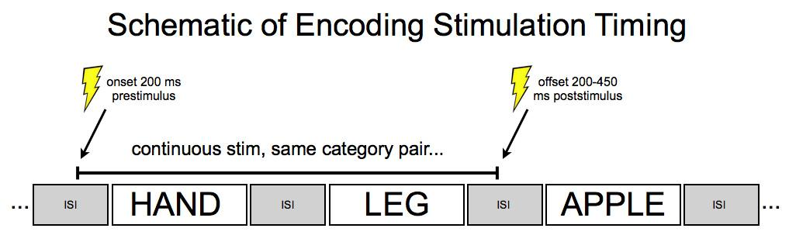
Assignment of List to Stimulation Condition:
- Out of the full set of 25 lists in a session, 5 lists will be randomly assigned to the null condition--i.e. no stimulation for the entire list. The remaining 20 lists will be randomly and evenly assigned to the hippocampus/EC conditions.
- The order of hippocampus/EC stimulation conditions will be blocked within a participant and counterbalanced across participants. Blocking the design within participant will minimize time spent manually updating settings on the stimulator.
- The order of stimulation within a list (i.e. whether the list begins with a stim ON pair or a stim OFF pair) will be randomly assigned to each list, with the constraint that at the end of the session, 10 lists will belong to one condition and 10 lists will belong to the other (the remaining 5 lists per session will be completely no-stim).

Experimental Design Power Analysis (assuming 25 lists/session and 2 sessions)
- The experimental design shall be statistically powered to have at least a 90% probability of identifying a 0.7 standard deviation difference between the stimulation and no-stimulation conditions.
- The power analysis estimated power to detect an overall difference recall between stim and no stim trials. The probability of recalling a given word in the no-stim condition was modeled as a binomial distribution with p = .5. For the stim condition, probability of recall was also modeled as a binomial with p = (.5)+(.7)SD, where SD for each simulated subject is drawn from the empirical distribution of within-subject across-session SD in overall recall performance, for all participants in the pyFR dataset. Random draws from these binomial distributions were simulated jointly over number of trials within a patient and number of patients. This process was repeated 1000 times for each combination of # trials and # patients, and the proportion of t-tests that detected a significant difference between the conditions was used as the estimate of the design’s power.
- For the within-subject comparison of region, N_{min} = 12.

References
- Burke JF, Zaghloul KA, Jacobs J, Williams, RB, Sperling MR, Sharan AD & Kahana MJ (2013). Synchronous and asynchronous theta and gamma activity during episodic memory formation. Journal of Neuroscience, 33(1), 292-304.
- Long NM, Burke JF & Kahana MJ (2014). Subsequent memory effect in intracranial and scalp eeg. NeuroImage, 84, 488-494.
- Suthana N, Haneef Z, Stern J, Mukamel R, Behnke B, Knowlton B & Fried I (2012). Memory enhancement and deep-brain stimulation of the entorhinal area. New England Journal of Medicine, 336, 502-510.

